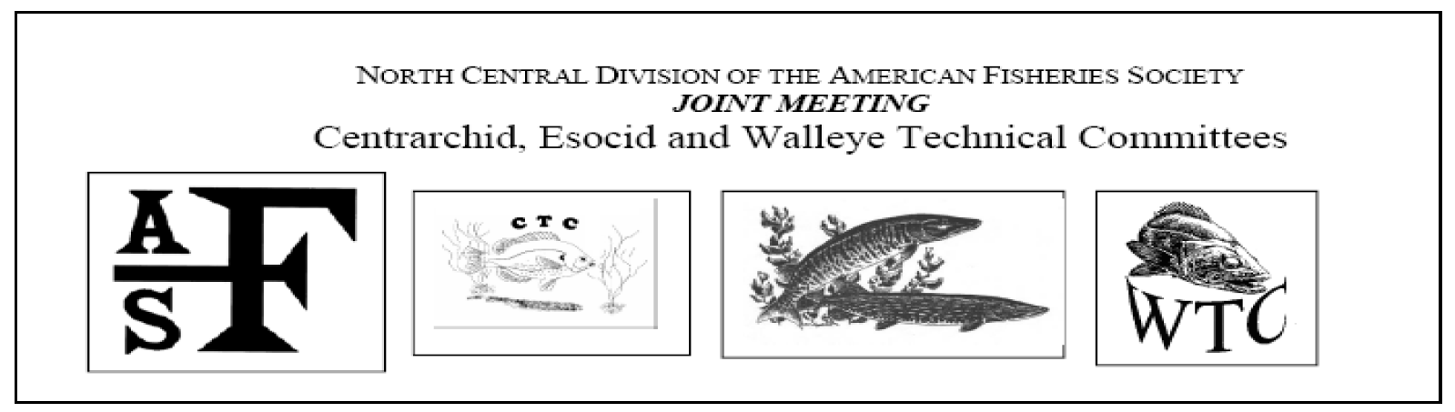
2016 Joint Meeting of the Centrarchid, Esocid, and Walleye Technical Committes – North Central Division of the American Fisheries Society
and featuring
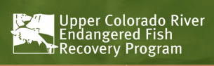
ANNOUNCEMENT AND CALL FOR PAPERS
Dates: July 25-28, 2016
Location: Ak-Sar-Ben Aquarium, Gretna, Nebraska
Lodging Location: Super 8 14355 NE-31, Gretna, NE (1 402 332-5188)
http://www.super8.com/hotels/nebraska/gretna/super-8-gretna/hotel-overview
A block of rooms have been reserved until June 25, 2016 at a rate of Single ($61.99/night + tax), and Double ($71.99/night + tax), Available under the name Fisheries Technical Committee Meeting (holding 30 rooms)
Registration Cost
Cost is anticipated at $60 for the entire meeting, which includes a fish fry or BBQ social Tuesday; morning and afternoon breaks, lunch and dinner on Wednseday; morning break on Thursday. Students are half price. A continental breakfast is available at the Super 8 in Gretna.

Continuing Education
A continuing education workshop is planned for Tuesday, July 26th. The topic options will include: Habitat Improvement Workshop (Site Visit Included), Developing Methods for Sportfish Control, Upper Colorado Endangered Fishes Recovery Program, and an Optional Free Float Trip for the first 30 registrants. Cost is anticipated at $50 per person.

Registration and Presentation Submittal
If you have a paper for inclusion please forward the abstract to John Bruner (jbruner@ualberta.ca). Meeting registration will be via email to Hilary Meyer at Hilary.Meyer@state.sd.us. We will accept payment by cash or check at the door. Sorry, we are not equipped to accept credit cards or other forms of electronic payment. Deadline for registration is June 17th, 2016. Hope to see you there!

